**SQL for Business Analyst**

**Click this following link for the step by step code**: <https://github.com/arummuktip/SQL-Projects/commits/master/SQL%20for%20Business%20Analyst/SQL%20for%20BA.sql>

**QUERY FOR SINGLE TABLE**

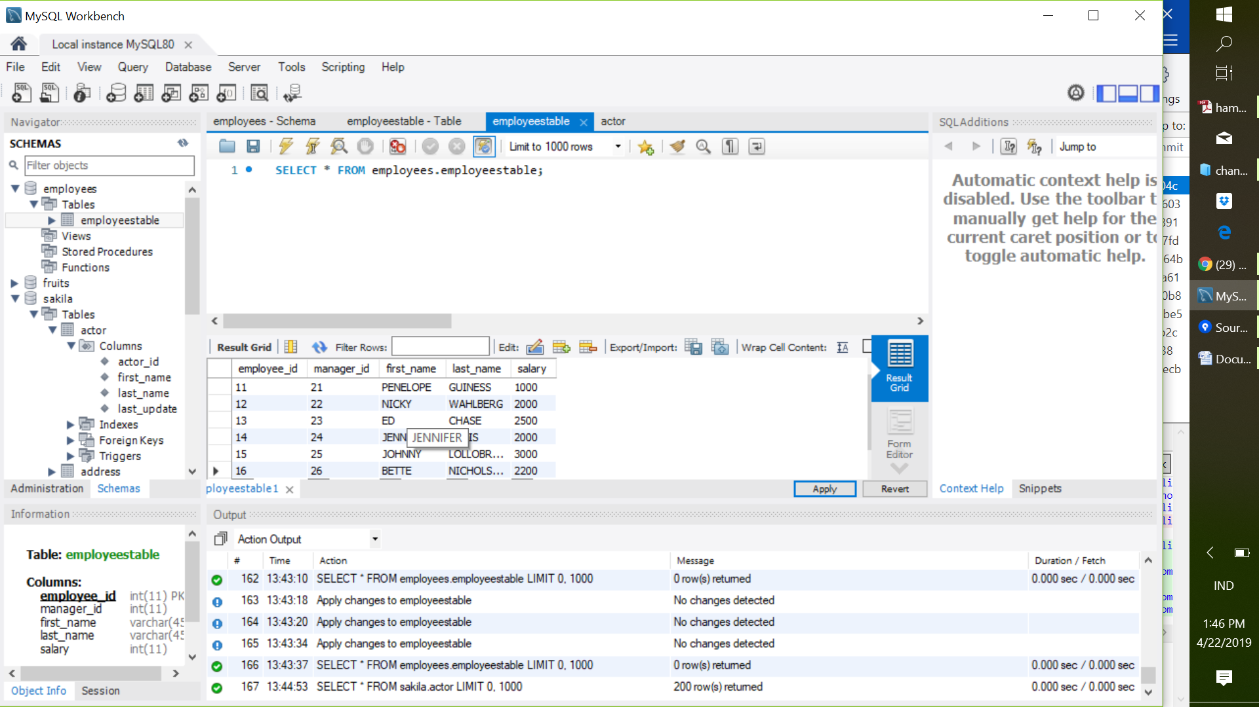

**EXAMPLES**

**Select -** the SELECT statement is used to select data from a database.

**FROM -** FROM is used to mention the table from which you want to pull record

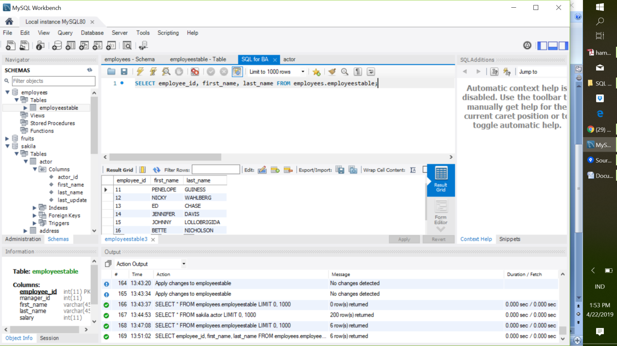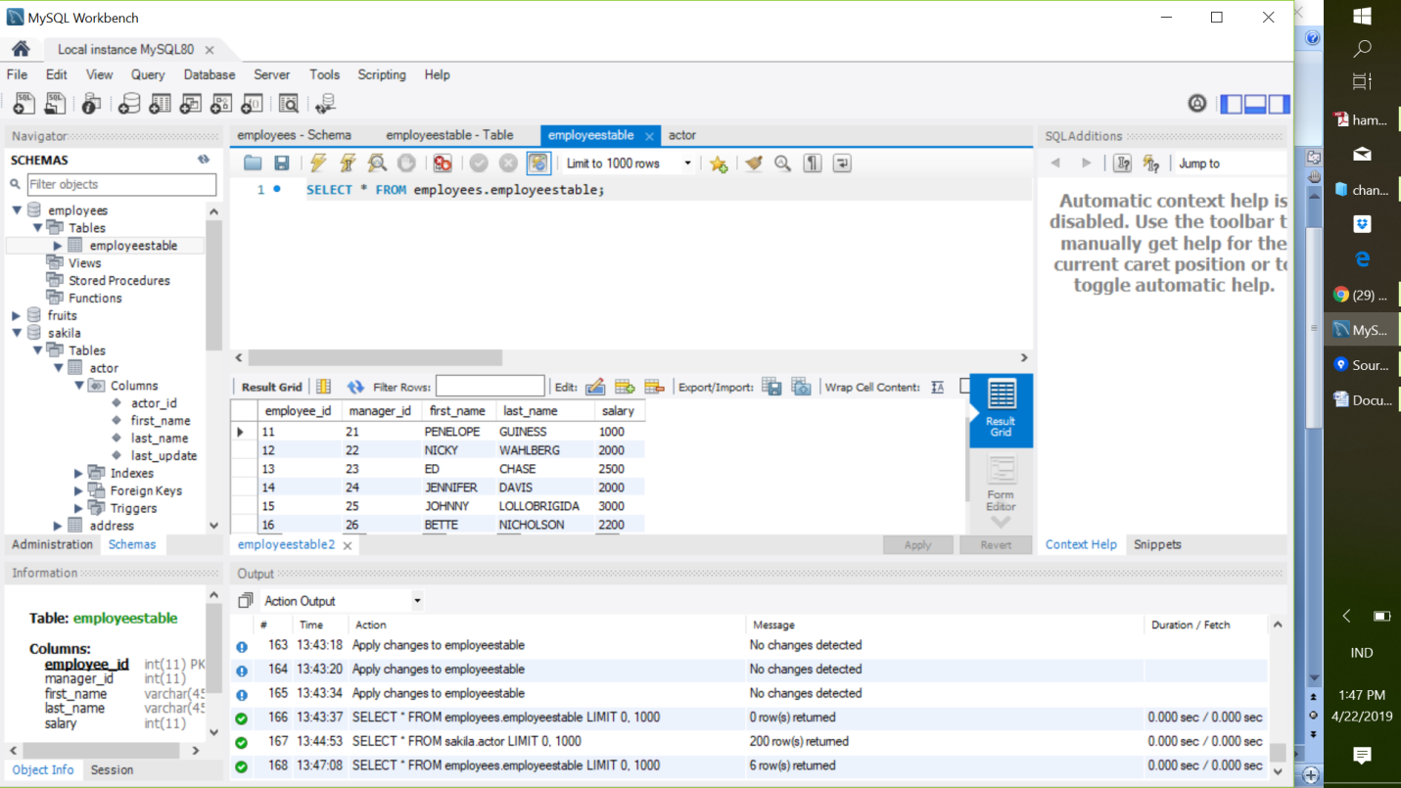

**WHERE -** the WHERE clause is used to filter records, and extra only those records that fulfill a specifies.

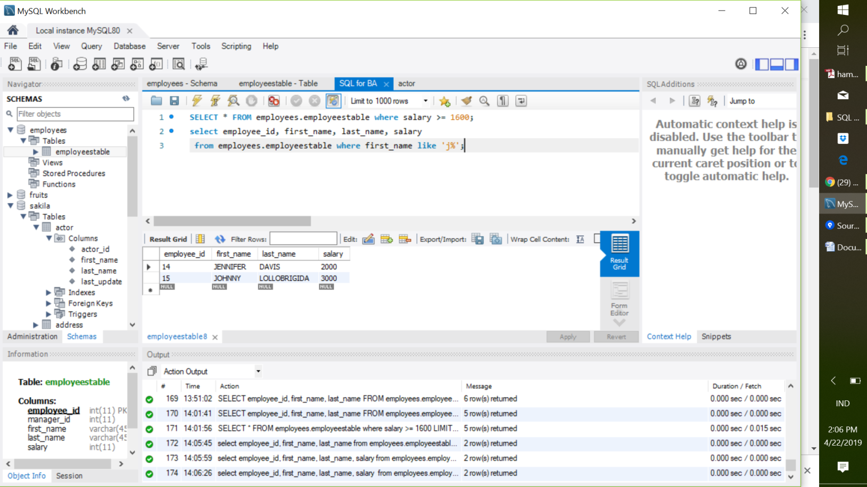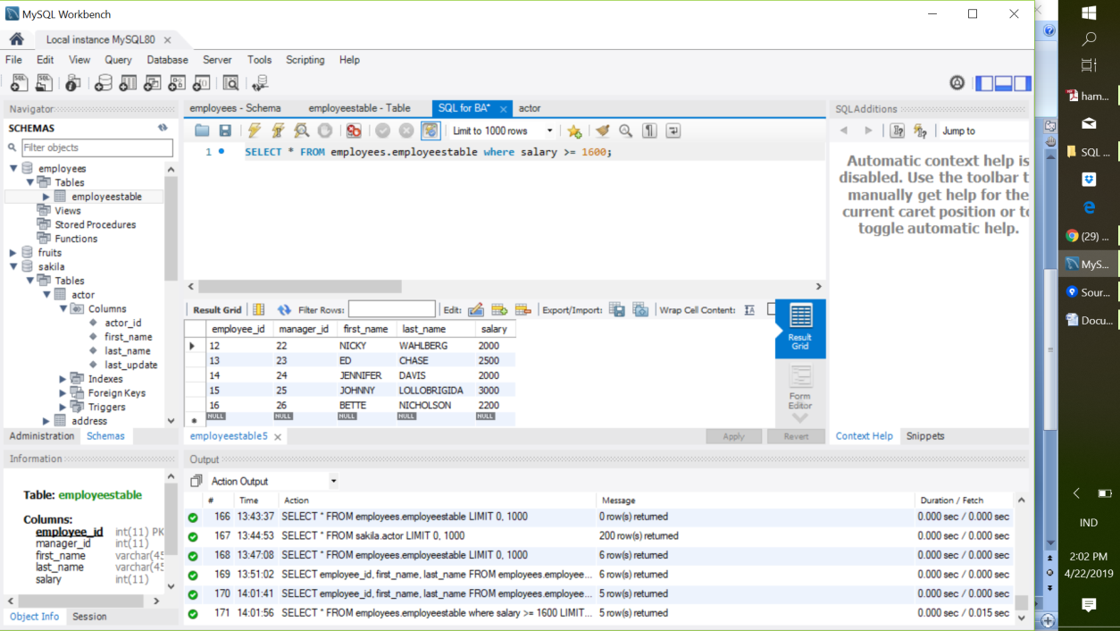

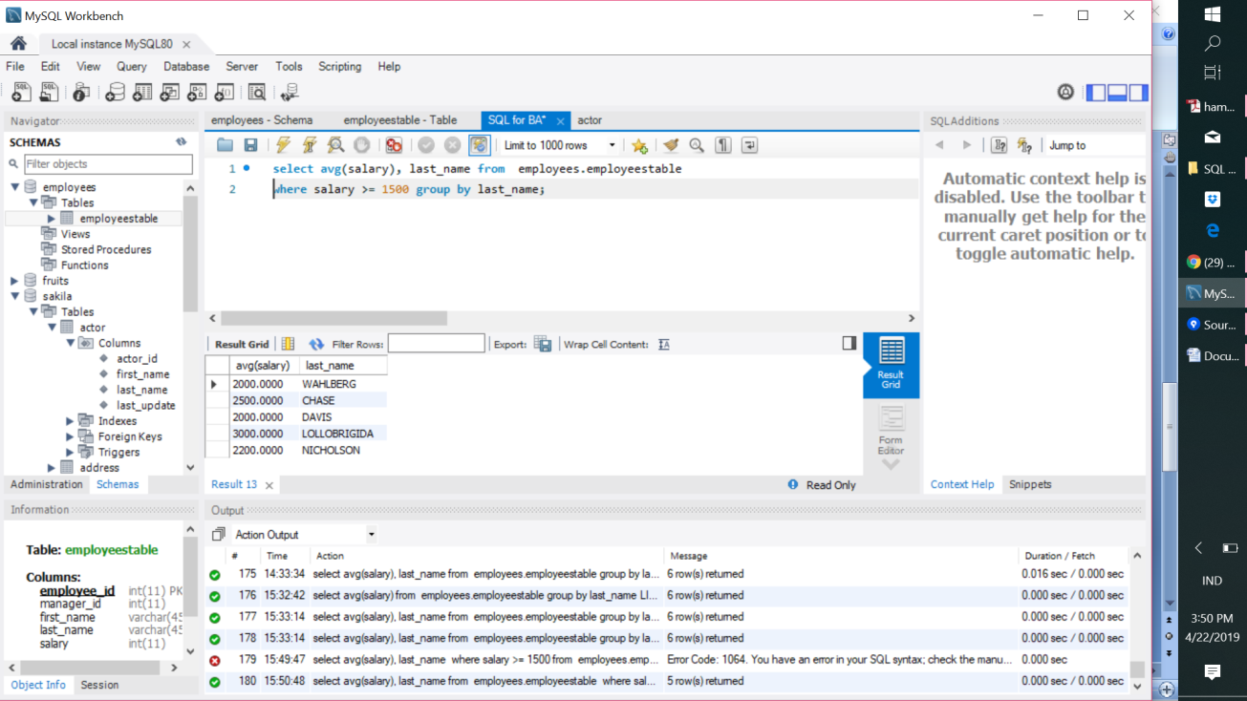**Group By -** Used with aggregate function (COUNT, MAX, MIN, SUM, AVG) to group the result-set by one or more columns

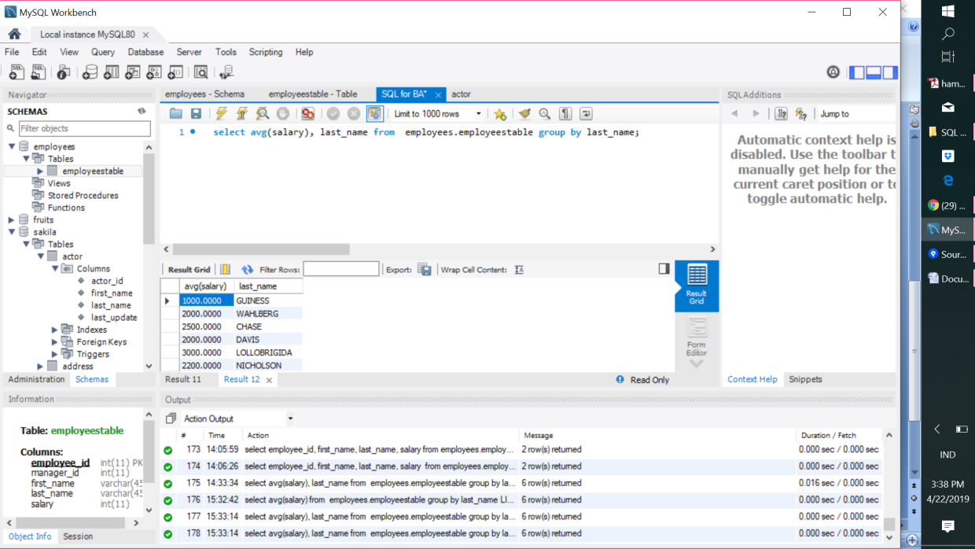

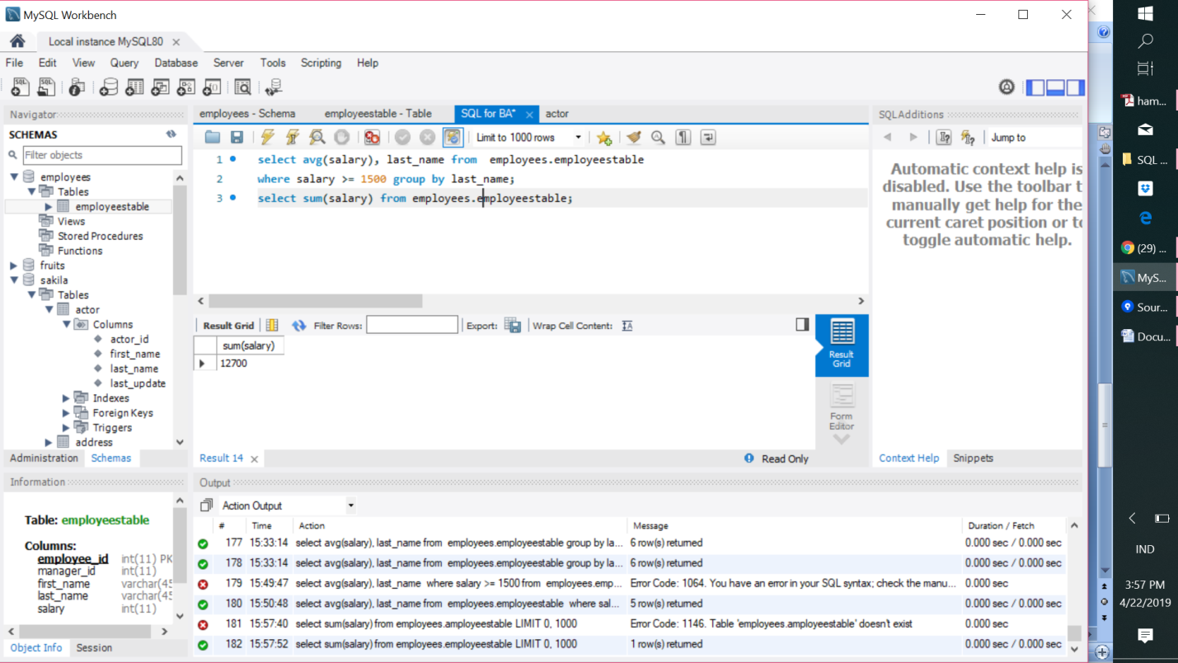

**Order By -** used to short the result-set in ascending or descending order

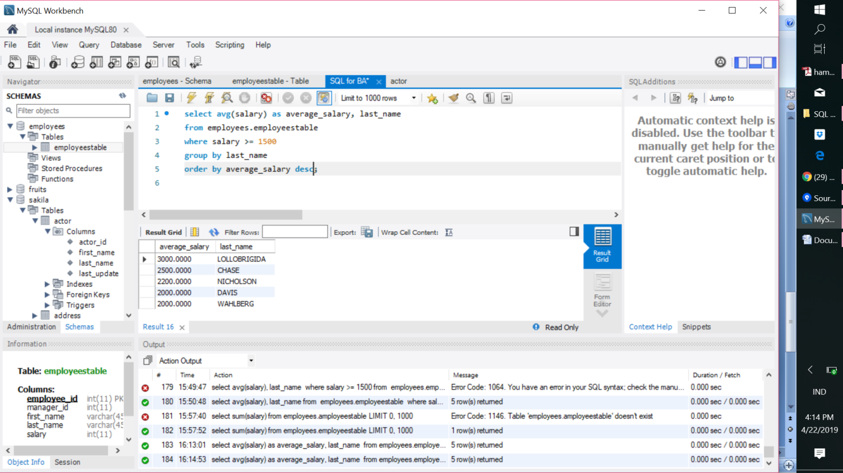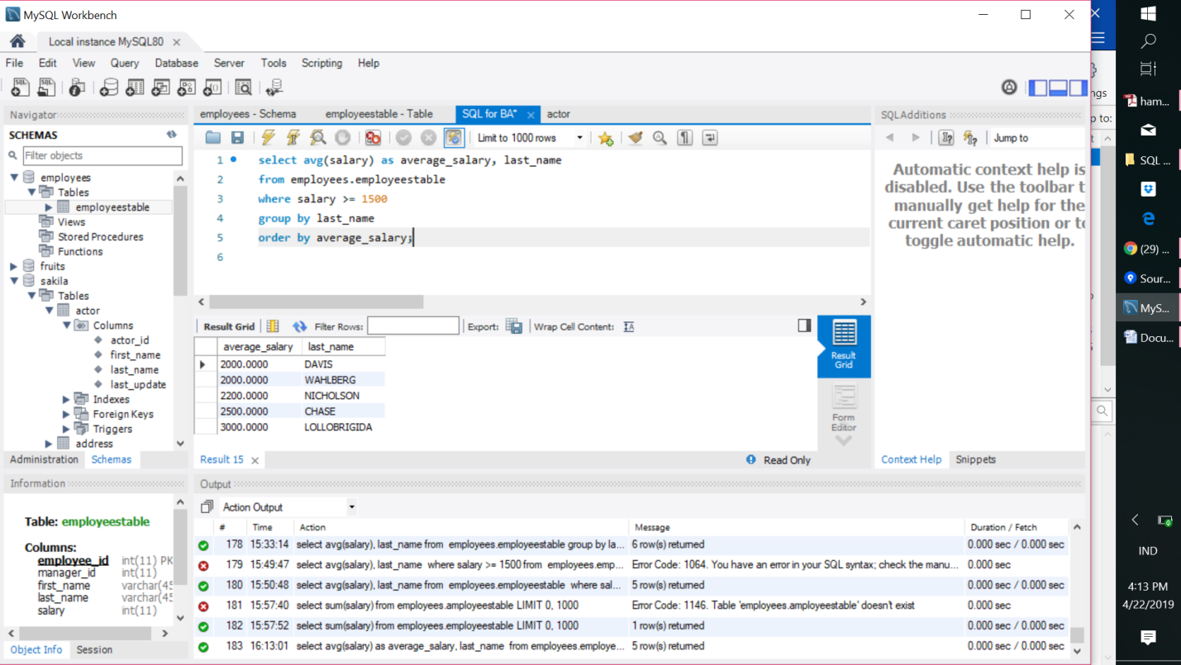

**Having -** The HAVING clause was added to SQL because the WHERE keyword could not be used with aggregate functions.

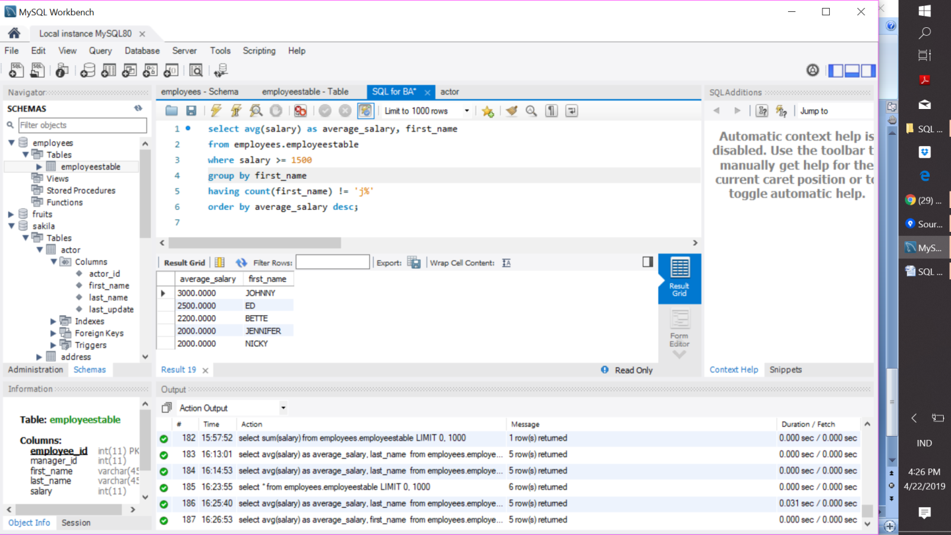

**InnerQuery -** Mean SQL Query within SQL Query

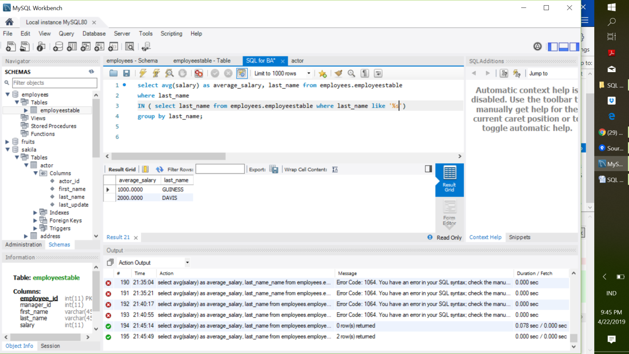

**QUERY for TWO or MORE TABLES**

**STUDENT TABLE EMPLOYEE TABLE**

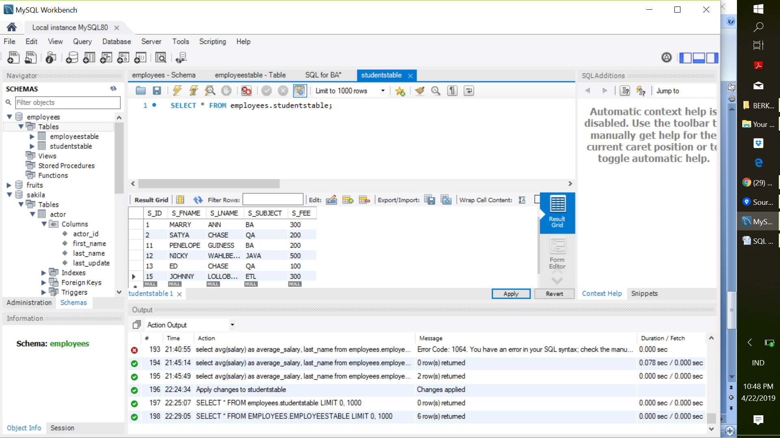 

**JOINS**

**C = INNER JOIN**

**A+B+C = OUTER JOIN**

**A+C = LEFT JOIN**

**C+B = RIGHT JOIN**

C

**INNER JOIN, Concatenation and "AS" Example**

**INNER Join:** Common record between STUDENT AND EMPLOYEE TABLE

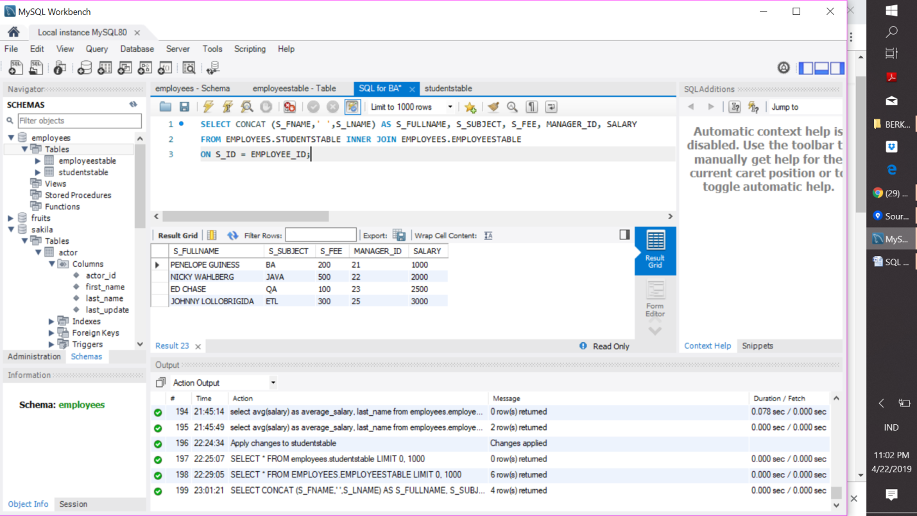

**Full OUTER JOIN, Concatenation and "AS" Example**

**Full OUTER Join:** Common record between STUDENT and EMPLOYEE table + record which are not common but are in STUDENT table + record which are not common but are in EMPLOYEE table. But, MySQL doesn't have syntax keyword FULL OUTER JOIN. I have to use combination of LEFT and RIGHT JOIN to obtain full joins and append the results from the second query to the first using a UNION ALL set operator. Then I must use WHERE clause to filters out all rows that found a match. (Those rows were already returned by the first query; the second query uses an "anti-join" pattern to return rows from employee_id that don't have a match.)

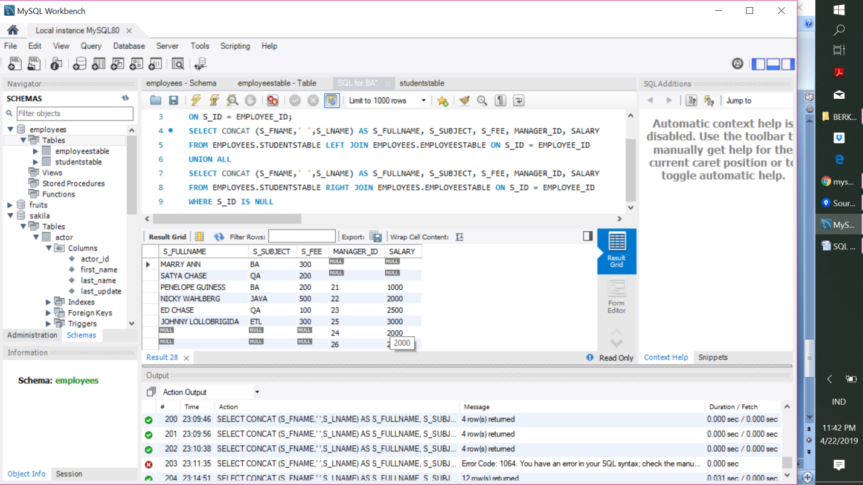

**LEFT JOIN EXAMPLE**

**LEFT Join:** Common record between STUDENT and EMPLOYEE table + record which are not common but are in STUDENT table.

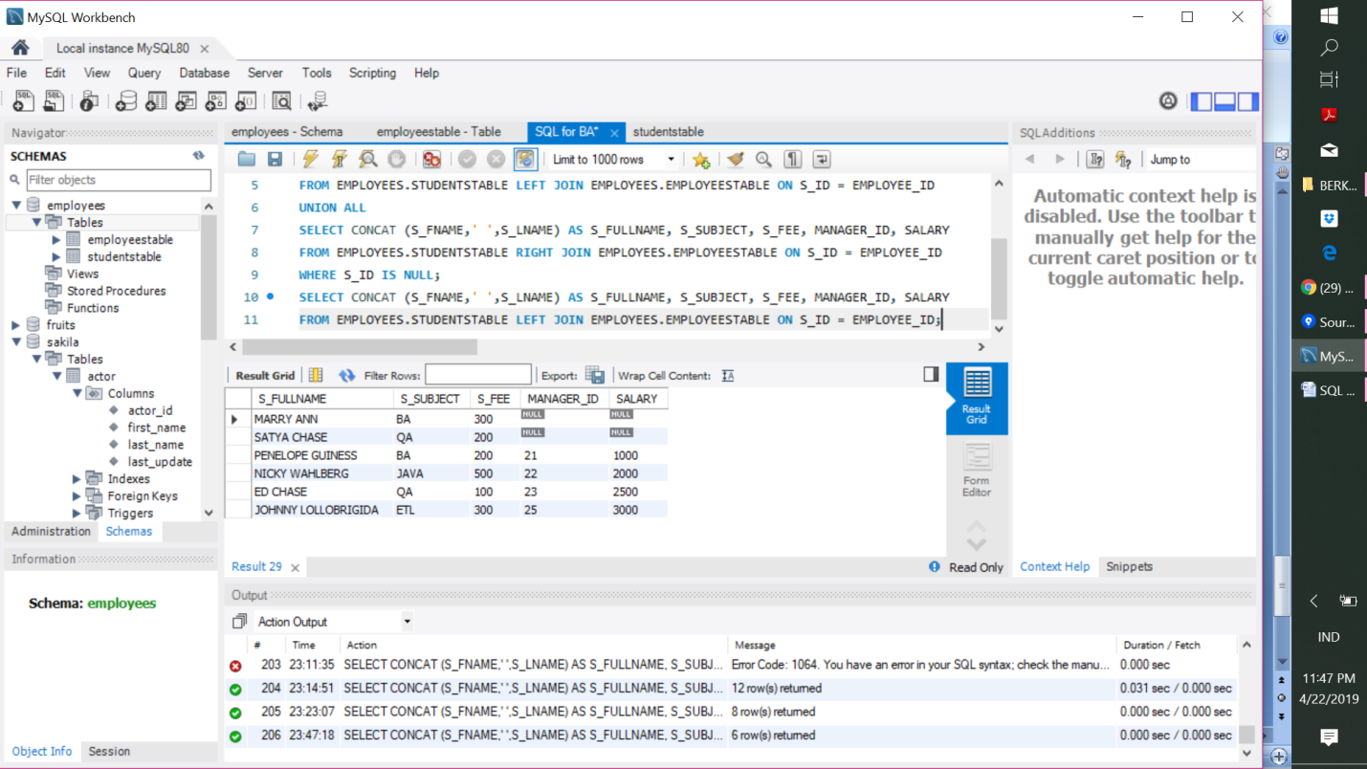

**RIGHT JOIN EXAMPLE**

**RIGHT Join:** Common record between STUDENT and EMPLOYEE table + record which are not common but are in EMPLOYEE table.

